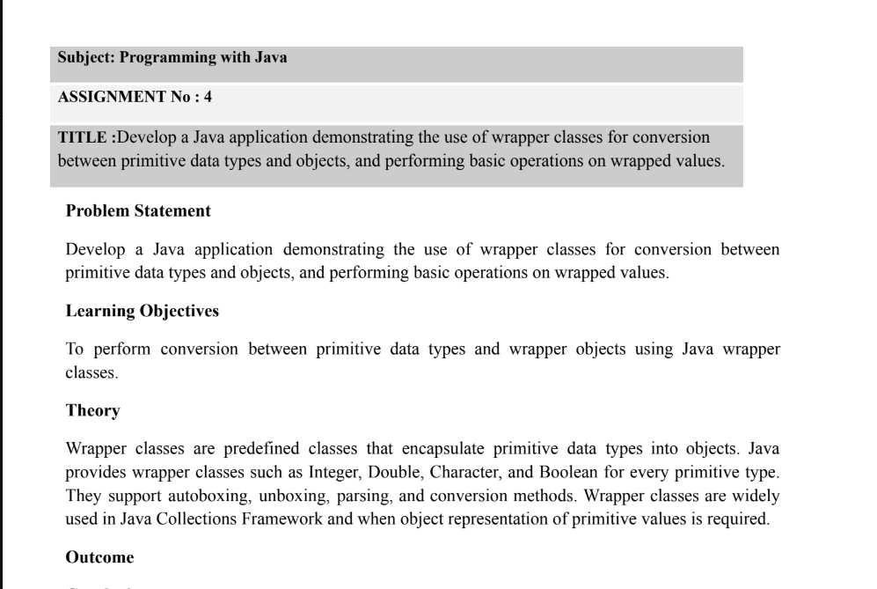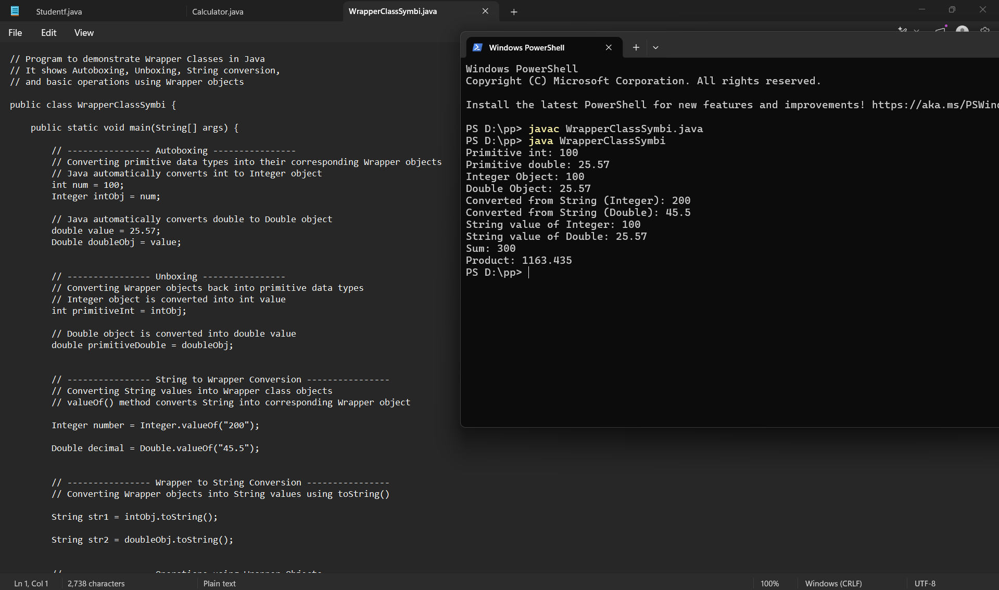
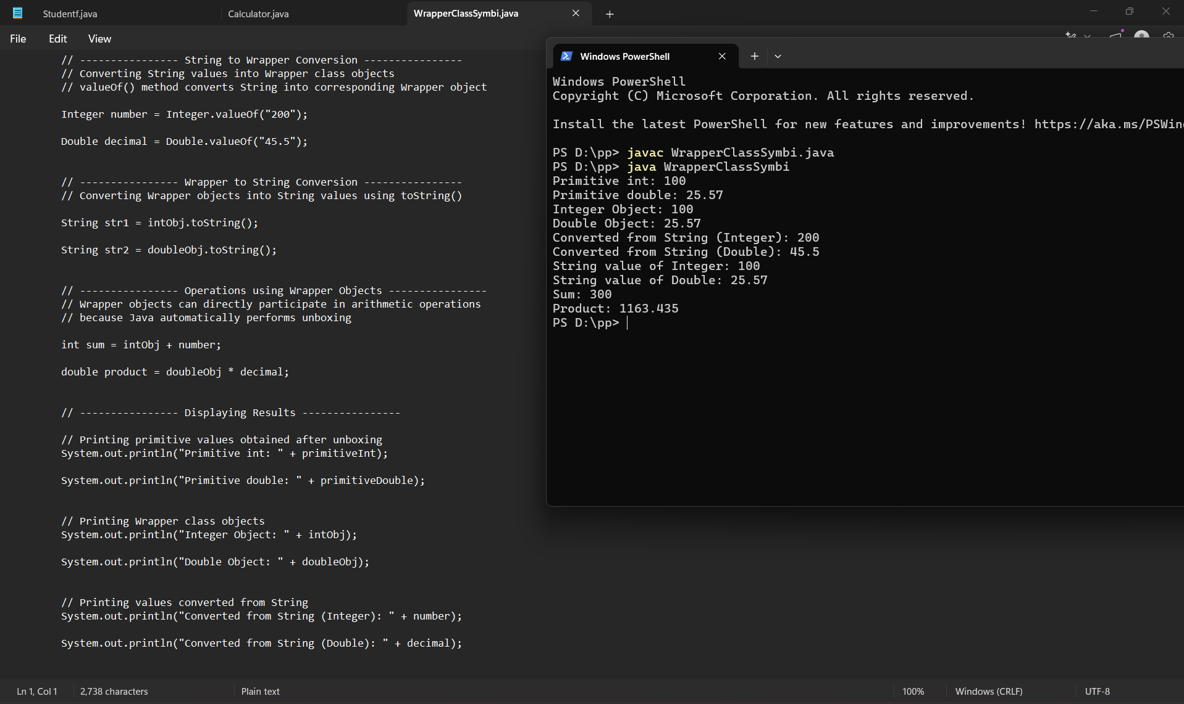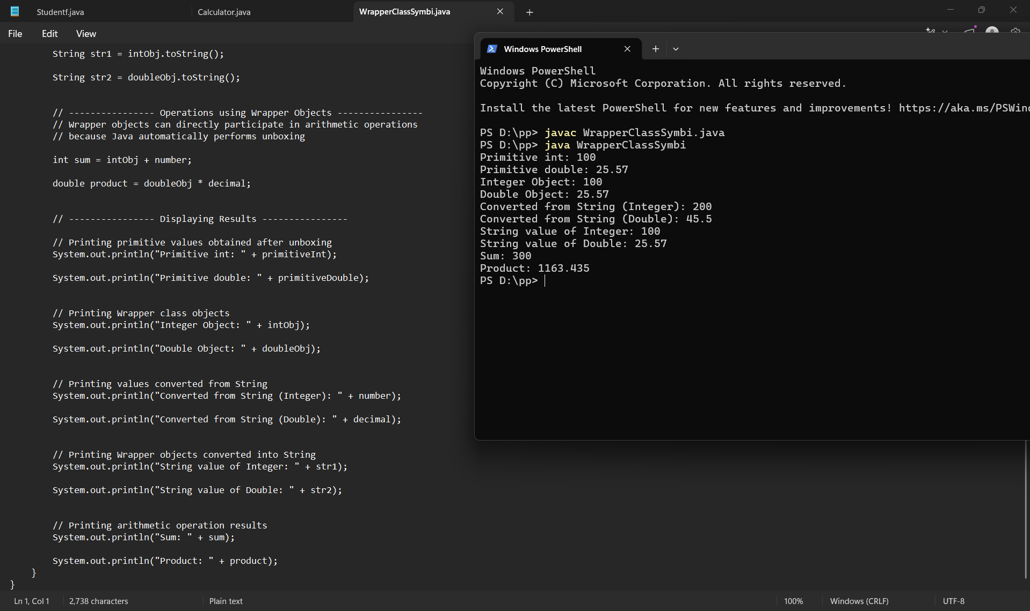
Conclusion
This assignment helped in understanding the concept and importance of Java Wrapper Classes. It demonstrated how primitive data types can be converted into objects (boxing/autoboxing) and objects can be converted back into primitive data types (unboxing). It also showed how wrapper classes provide useful methods for parsing, type conversion, and performing operations on wrapped values. Overall, the program enhanced understanding of object-oriented programming concepts and the practical use of wrapper classes in Java applications.

